**Patrick Sebiro**  
EME 6235 – Fall 2017  
Technology Project Management  
University of South Florida

**Midterm Assignment**  
Comparative Review of Authoring Technologies

Nowadays, choosing a technology is a challenge for instructional designers since they must select from a myriad of tools. Pundits argue using the right tool for the job; in reality, familiarity, availability, and skills influence our choices of technologies. In this review, we examine three tools.

**Adobe Captivate is** an authoring platform by Adobe to create responsive eLearning content, software simulation, and branched scenario in web format.

**Microsoft PowerPoint** is a presentation software by Microsoft. It is used to create dynamics presentation. It is available with the Office suite, and it is still widely used to distribute eLearning contents.

**Adobe Dreamweaver CC** is a development tool use to create, publish, and manage website and mobile content.

**Tools Descriptions**

**Adobe Captivate features**

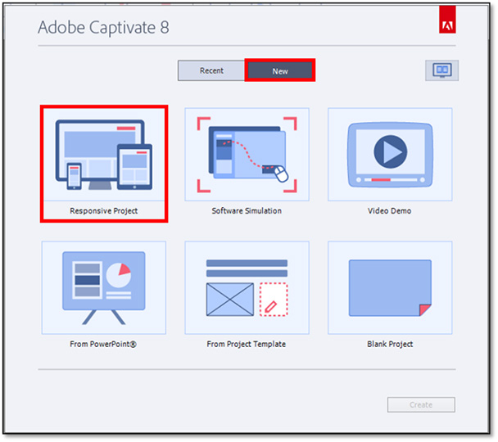

* Responsive design course
* Various learning interactions
  + Drag and drop
  + Highlight boxes and zoom areas
  + Buttons
  + Menu & navigation
* Software demo
* Text to speech & closed captions
* Quiz, questions, and knowledge checks
* Smart shapes & animations
* Object states and many more…

**Microsoft PowerPoint features**

* Great visual impact
* Smart art
* Insert shapes or images
* Slides transition
* Objects animation
* Embed and edit videos
* Easy picture editing
* Export presentation to various formats
* Organize and print slides effectively
* Most popular presentation software
  + Almost everyone has it
* Shorter learning curves

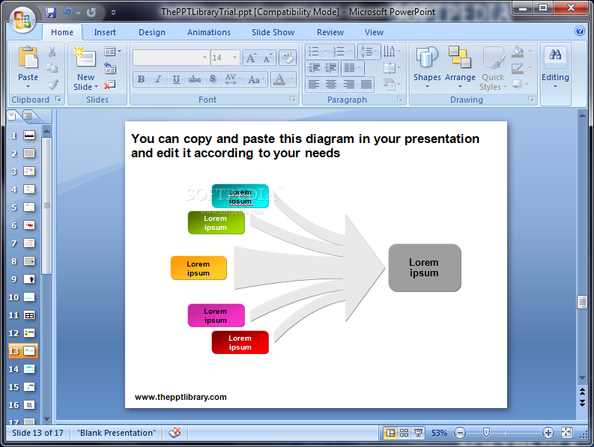

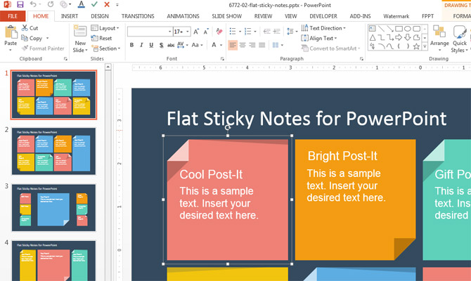



**Adobe Dreamweaver CC features**

* Responsive site
* Cloud creative image
* Preview website on multiple devices
* CSS editing
* Real-time browser preview
* New code editor
* Enhanced themes library

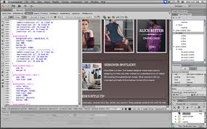

**Pricing**

**PowerPoint**

PowerPoint is offered as part of the Microsoft Office Suite; Office 365 for cloud based platforms and Office 2016 for desktop clients. The following offerings are listed on the Microsoft website:

|  |  |  |
| --- | --- | --- |
| **$99.99** | **$69.99** | **$149.99** |
| * Office 365 Home buy or rent for $9.99 per month * Includes: word, excel, PowerPoint, Outlook, one note, Access, Publisher and desktop copy of Office 2016 | * Office 365 Personal buy or rent for $6.99 per month * Includes: word, excel, PowerPoint, Outlook, one note, Access, Publisher. OneNote | * Office home & student 2016 (one-time purchase) * Includes: word, excel, PowerPoint, and OneNote |

**Captivate & Dreamweaver**

Adobe groups products by categories and has a range of offerings.

|  |  |
| --- | --- |
| **Captivate** | * $29.99 29.99 /mo. * $1099.00 full licensing price * $349.00 Students & Teacher Edition * $449.00 for Upgrade |
| **Dreamweaver CC** | * $69.99 as part of the Adobe Creative Cloud and includes: illustrator CC, Photoshop. * $19.99/mo. for single application |

**Industry**

Captivate, Dreamweaver and PowerPoint are predominantly used in Education and Business. Most corporate learnings are delivered via PowerPoint; there is an increase in the use of Captivate and other similar tools to distribute learning contents. Dreamweaver popularity is fading amongst web developer; more straightforwardand free tools such as notepad++ are becoming the tool of choice.

**Comparative review**

Today, in all industries, there is an increase in the use of mobile or handheld devices. To accommodate this rise, responsive design has become a top requirement on most request for proposal. This provision gives de facto upper hands to Captivate and Dreamweaver. Both products benefit mainly from the innovative reputation of the Adobe brand that is also known for having complex licensing and higher price structure. Adobe has developed a solid partnership with colleges by providing free licensing or lower licensing cost for students and faculties. Depending on the field of studies, most students enter the job market with a working knowledge or basic to intermediary skills of Adobe products (Photoshop, Captivate, Dreamweaver, etc.)

At first, the instructional design world acclaimed Captivate for its ability to publish learning content as HTML that Learners can access via web browser. Designers could develop compelling eLearning materials with no programming experience. While this trait is no longer unique, Captivate does offer a gentle learning curve since skills acquired from using PowerPoint or other Adobe product can easily be transferred to Captivate. Adobe has a rigid licensing approach that limits software usage to version licensed. Unlike Microsoft or other software vendors, there is no free upgrade. As most organizations prefer a scalable solution, this restriction limits users’ ability to access new innovative features unless they chose to absorb the cost of a new license.

On the top of the traditional HTML features, Dreamweaver offers client-side scripting such CSS and JavaScript. It includes a visual design with live view and easily integrates into most development environments. Barriers to adoption include skills, pricing, and the licensing challenges of the Adobe brand. Also, many companies are offering entire web platform via bootstrap codes and web design template that users with no web experience can efficiently use to develop to produce powerful websites.

PowerPoint remains an everyday tool; it is available to almost anyone using a Windows PC with a version of an installed version MS Office. Newer versions of PowerPoint include a storyboarding tool and the ability to view slides via a web browser. The web feature does not make the presentation ready for publishing to other web platforms, additional configuration is necessary. More so, competing products advertise compatibility PowerPoint slides as a selling point. In the business world, most users possess advanced development skills with PowerPoint; therefore, they choose to create presentations in PowerPoint and upload to other tools for more design and publishing. There is no additional cost in licensing PowerPoint; corporations get a free upgrade as long as the license is still active. To open a PowerPoint presentation, users must have the product installed. The wide availability of the office suite mitigates this risk.

The table below compares the product per features:

|  |  |  |  |
| --- | --- | --- | --- |
|  | **Captivate** | **DreamWeaver** | **PowerPoint** |
| **Price\Cost** | High | High | Low |
| **Scalability** | Low | Low | High |
| **Performance** | High | High | High |
| **Learning curve** | High | High | Very low |
| **Market Availability** | Medium | Low | Very high |
| **HTML publishing** | Yes | Yes | Limited |
| **Media Support** (audio, video, animations, images) | Yes | Yes | Yes |

Instructional designers have a penchant for Captivate or similar software since it includes assessment tools, quiz reporting, can integrate to learning management systems, and tracks learners progress. It can be used to develop scenario-based learning for complex skills as well as informational knowledge. PowerPoint remains the everyday tool in all industries, it allows for easy sharing of information, its popularity is not about to diminish. Dreamweaver is a development tool, to use by web developers. It requires some love of maintenance since upgrade to other development platforms such as the .net framework can affect its functionalities.

R. Fuller famously said that: “To change something, build a new model that makes the existing model obsolete” In researching this review, we found that there are countless tools available with similar features. None of which can entirely replace the other. Companies consider the cost-benefit ratio before deciding to invest in technology. A couple of years ago, the executive management declined my request to license Storyline. To them, using PowerPoint with paper/manual assessment to deliver the training was equally effective; to an extent, they were right. It is still unclear as to whether one technology provides higher value than another. The actual value added by can emerge only after reviewing the industry, cost, similar technology, skills, maintenance, and scalability.

Courses Authoring Technology

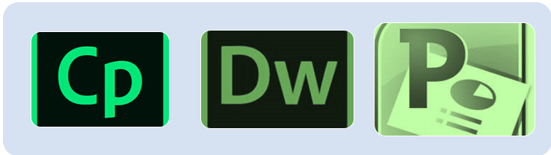

* Smart eLearning Design
* Responsive eLearning authoring
* Import objects and animations from PowerPoint
* Intuitive user interface
* HTML5 Publishing
* Comprehensive quiz and assessment



**Reasons for choosing Captivate, Dreamweaver, or PowerPoint**



* CSS & HTML Editing
* Real-time browser review
* Multi Monitor Support
* Simplify User experience
* Photo and image Marketplace
* Streamline HTML 5 audio and video
* Smart art
* Presenter view
* Picture and image formatting
* Integration with excel for charts
* Clipboard & Storyboard
* Slide Show & animations

**Source**

https://[www.adobe.com/products/captivate.html](http://www.adobe.com/products/captivate.html)

<https://products.office.com/en-us/what-is-powerpoin>

https://helpx.adobe.com › Dreamweaver CC › Tutorials

<https://www.digitalchalk.com/blog/15-benefits-of-using-powerpoint-in-elearning>

http://www.adobe.com/products/dreamweaver/features.html

https://products.office.com/en-us/buy/office

https://en.wikipedia.org/wiki/Adobe_Dreamweaver